*Step-by-step Guide to**Customize**your* ***GitHub Profile*** *with* ***Images***

**This pdf is designed to help you create a personalized GitHub profile that reflects your skills. You’ll learn how to:**

* ***Set up a profile repository that allows you to customize your public GitHub profile.***
* ***Add a README.md file to introduce yourself include images* *to the GitHub community.***

***Step 1: Create a Repository repository exactly as your GitHub username***

*Log in to your GitHub*

**

*Click the + sign (at the top) and choose New repository.*

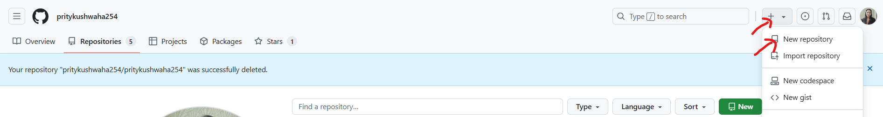

*Name your repository the same as your GitHub username .*

* *For example, if your username is pritykushwaha254, name it pritykushwaha254.*
* *Pritykushwaha254 is a special repository now. You can also see this information in below snap:*

*“Make sure it’s public and initialize it with a README to get started”*

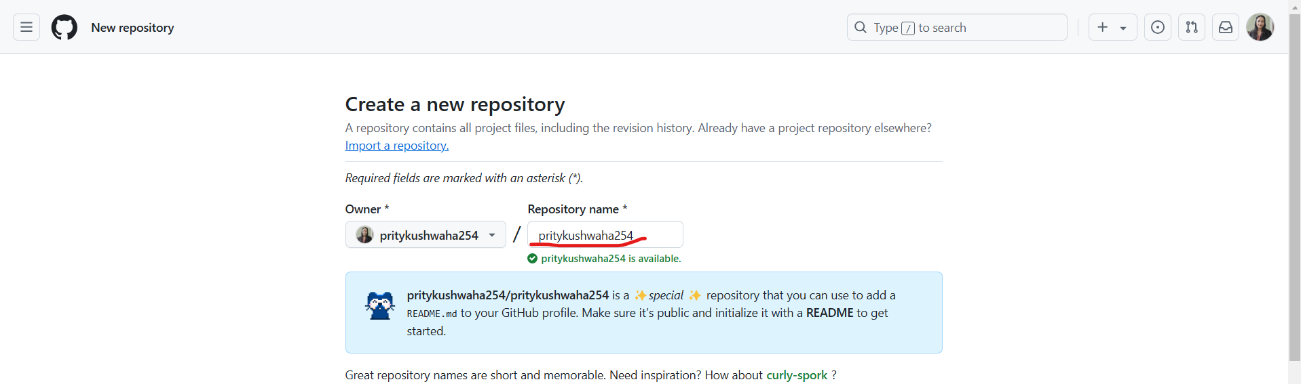

*Click Public and check the box to Add a README file.*

* *You need to make your repository public then only it will visible to all.*

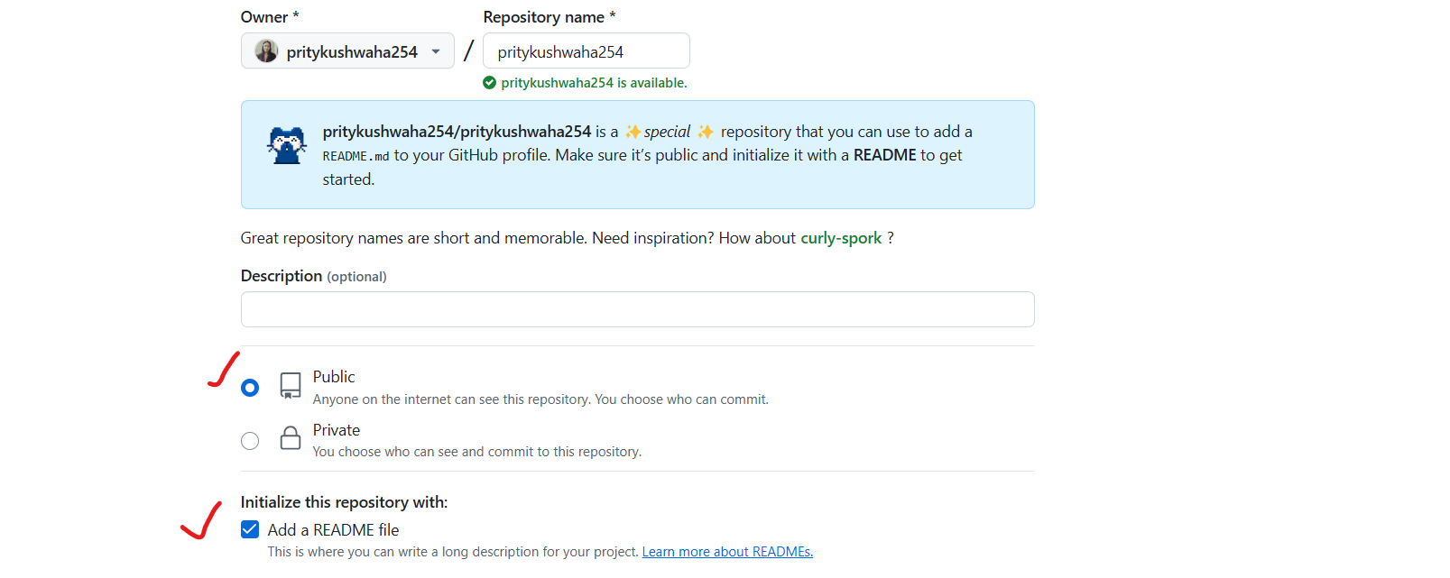

*Click on create repository.*

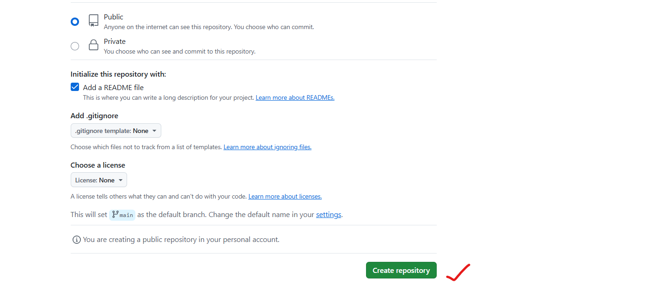

*When repository will create it will look like below :*

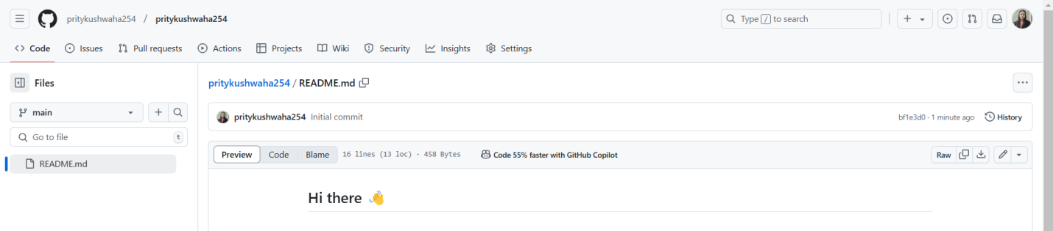

***Step 2: Write About Yourself***

*Open the repository you just created.*

* *You can find it from here…*

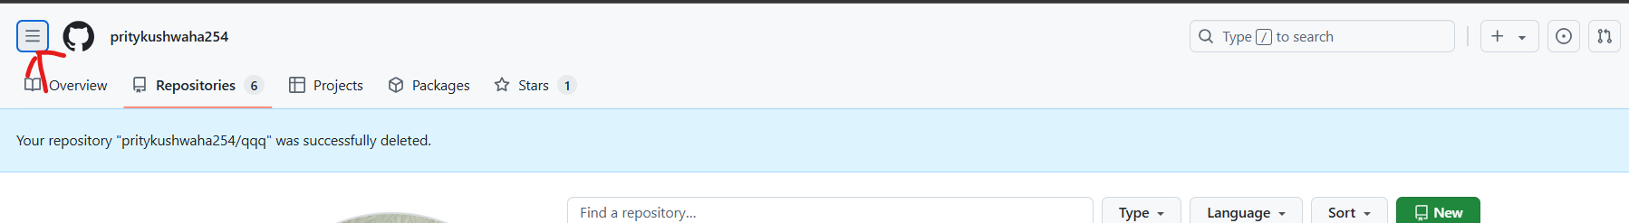

* *Click on your repository pritykushwaha254/pritykushwaha254*

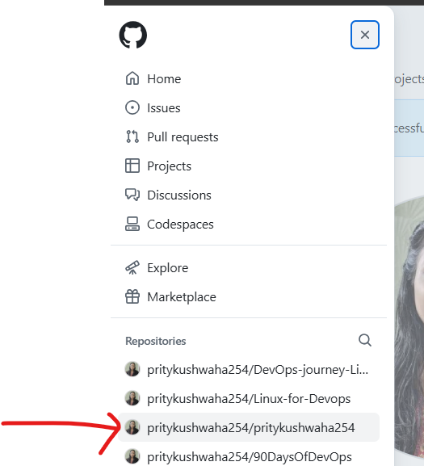

*Click the README.md file.*

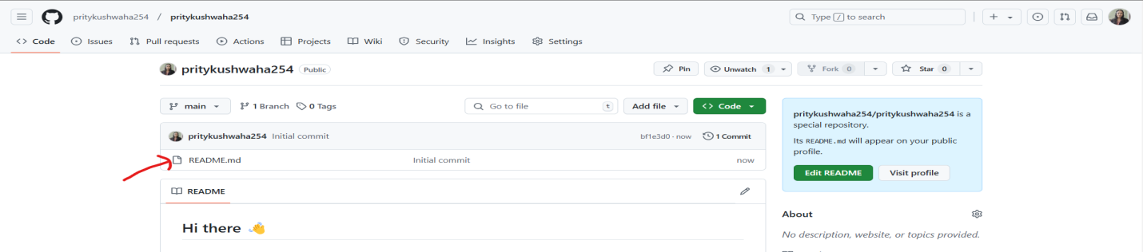

*Click the Edit (pencil icon) to change the text inside README.md file.*

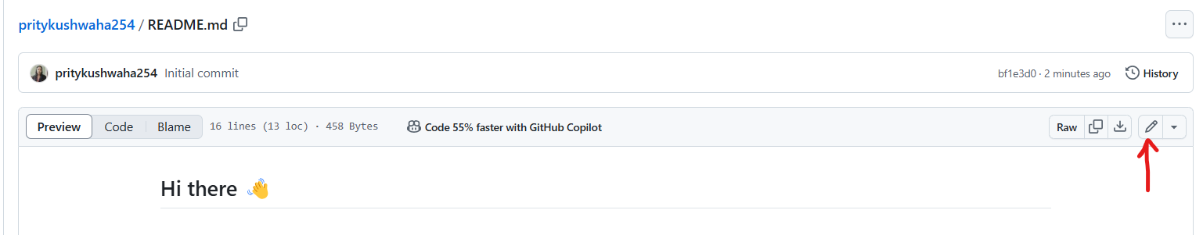

*When you will open your README.md file very first time, it will display the content of this file.*

* *Basically it hints how to make your profile.*

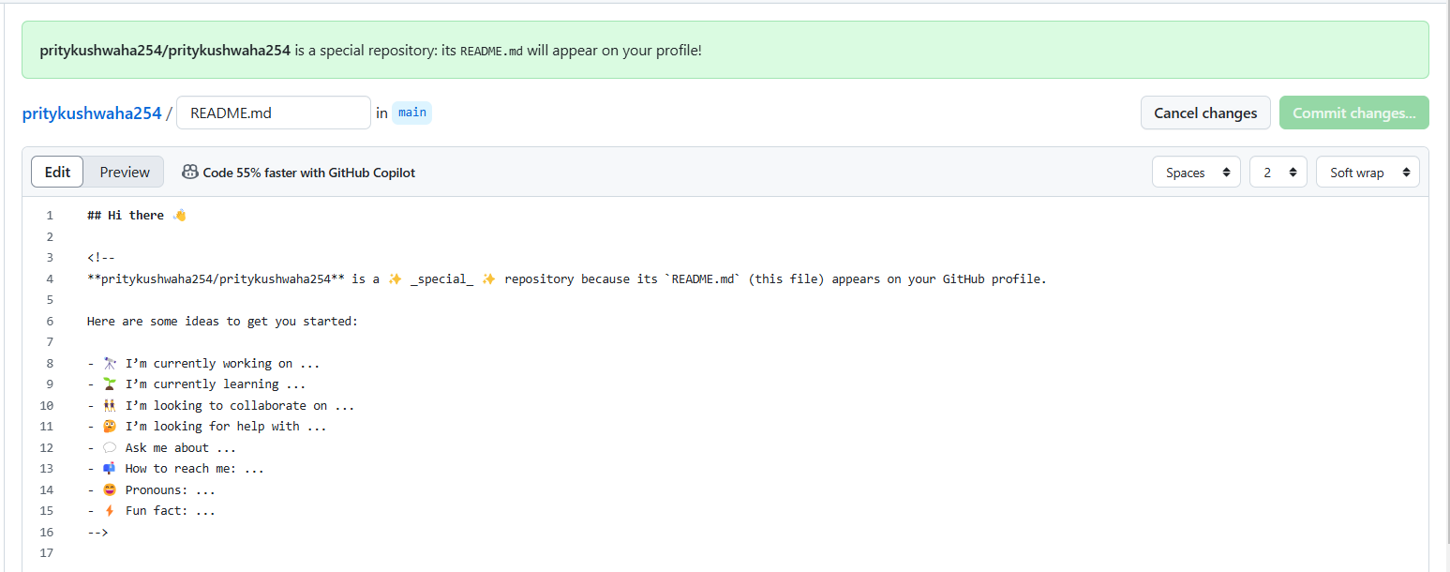

*You can customize it to showcase your skills, interest and many more. Edit according to you.*

* *For example: I have edited with my details, see below snap…*

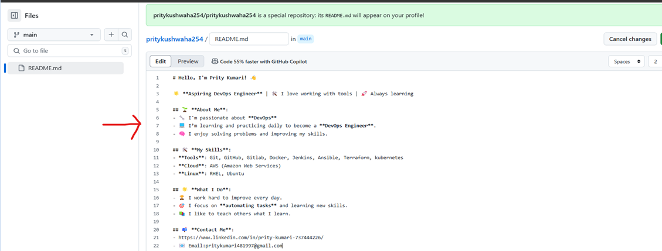

***Step 3: Save Changes***

*Scroll down and click Commit changes (this saves what you wrote).*

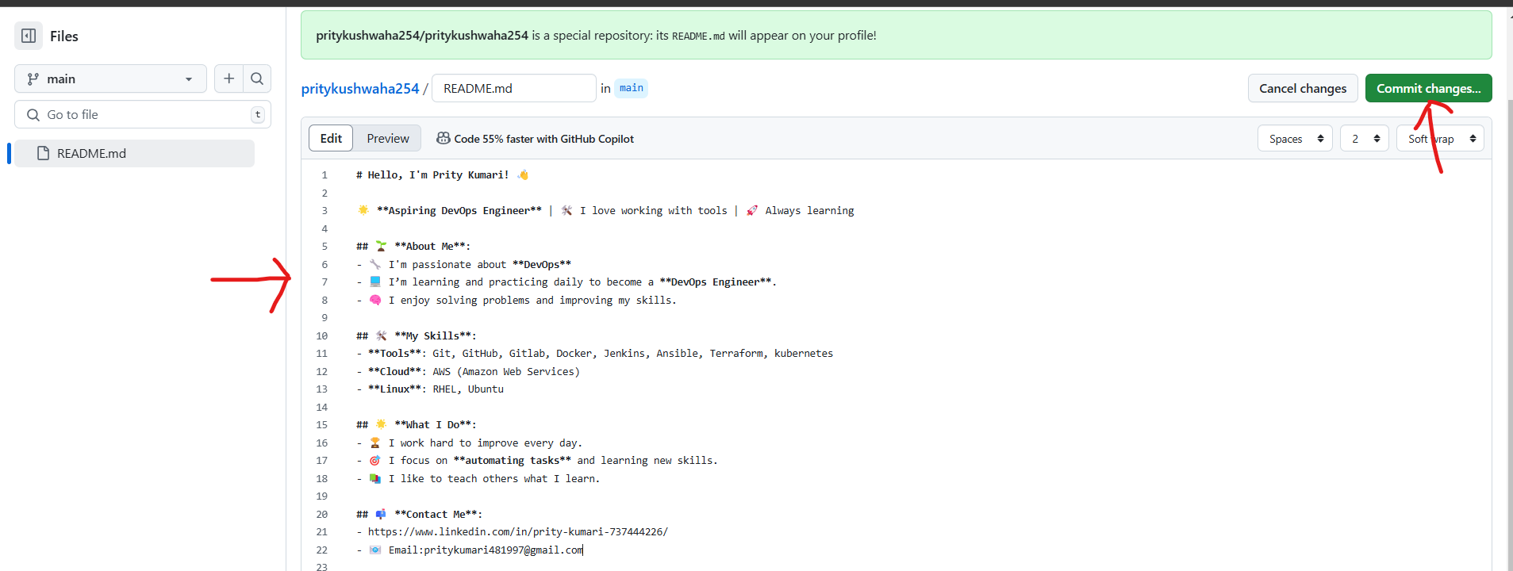

*After saving it will look like below:*

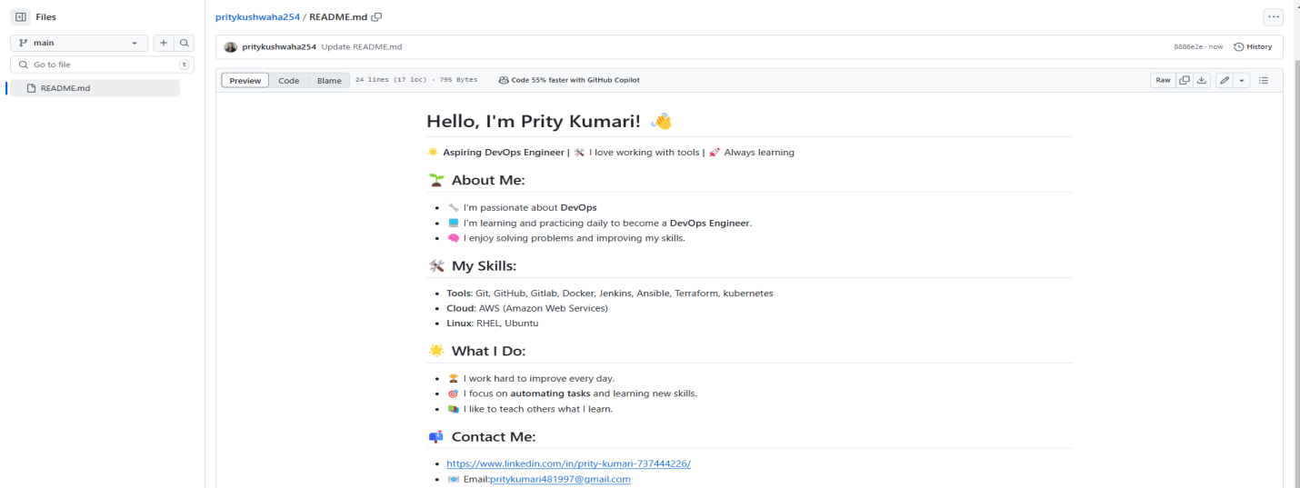

***Step:4 See the Changes***

*Go to your profile page by clicking your picture at the top right.*

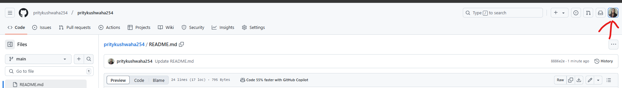

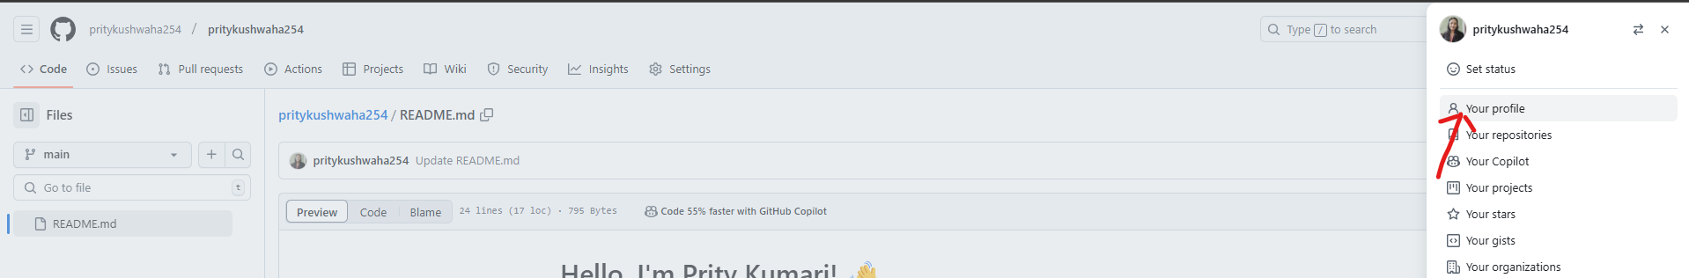

*You will see your new information:*

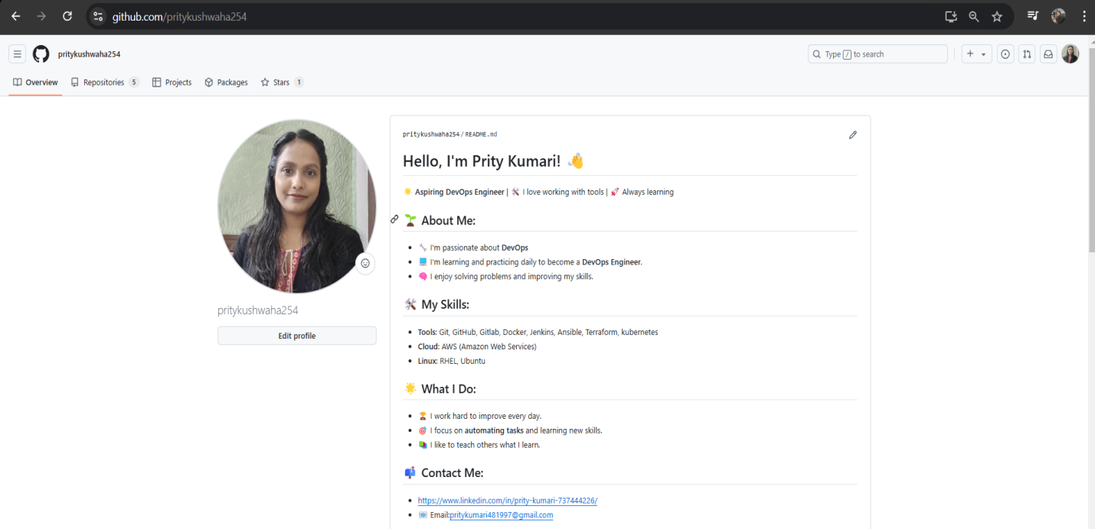

*-----------------------------------------------------------------------------------------------------------------*

**Add the Image to Your README File**

*Open README.md file and click* ***Edit*** *(the pencil icon).*

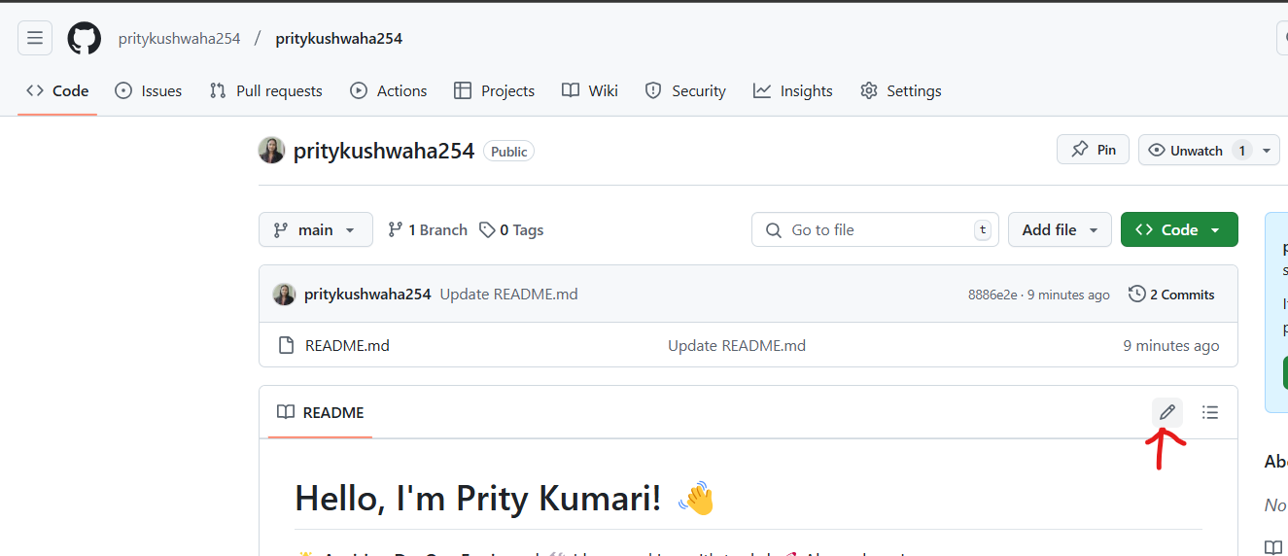

*Right click on Issues and then click on open link in new tab, go to that tab and click on new issue.( you can also use another way)*

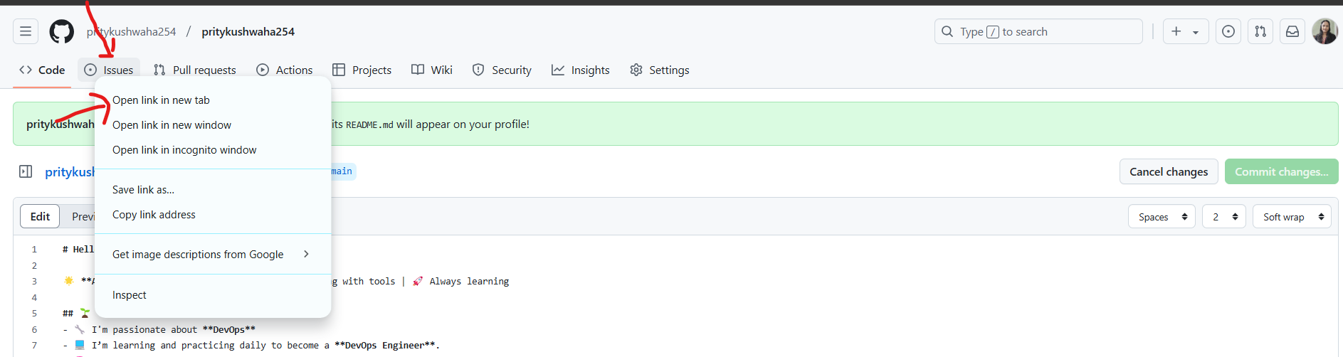

*Click on New issue…*

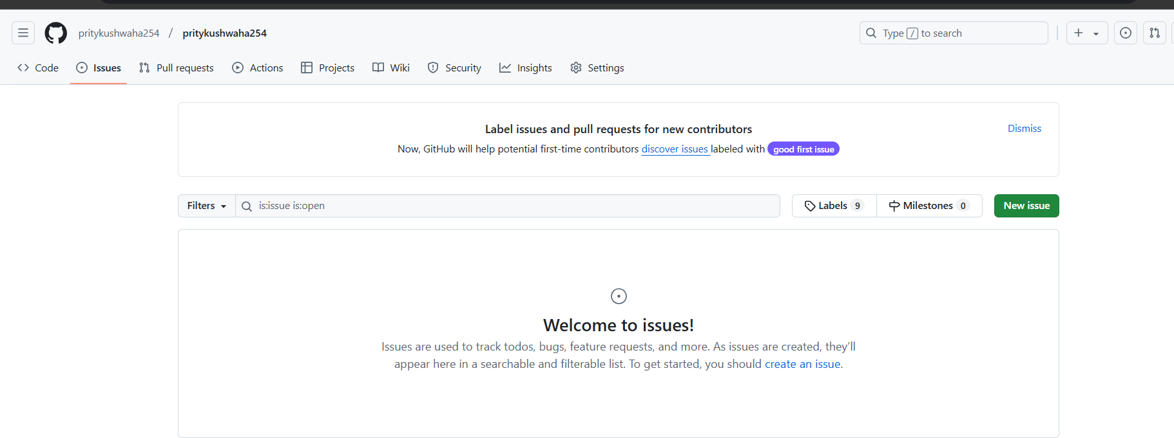

*Drag and drop your image from your file explorer to GitHub new issue, as shown in snap below:*

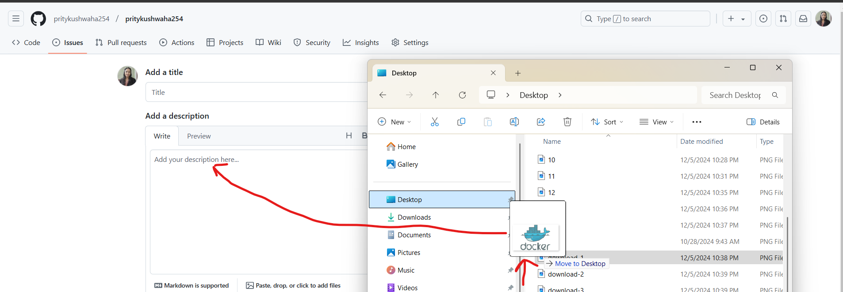

*As soon you drag and drop your image to GitHub new issue, link of your image will appear there.*

* *Copy your image link.*

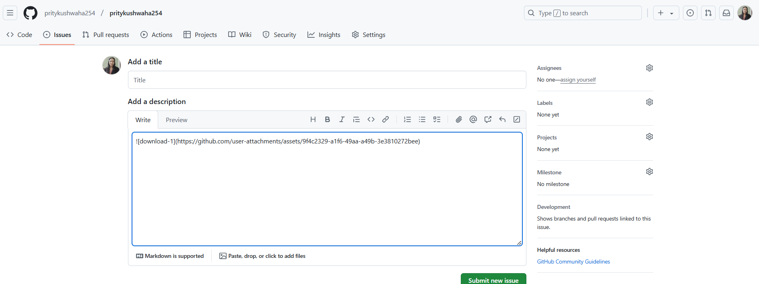

*Now come to your previous tab and paste your image link where you want your image to be display to whole world.*

* *You can add multiple images follow same steps.*
* *For example I have pasted image link where I have written my skills.*

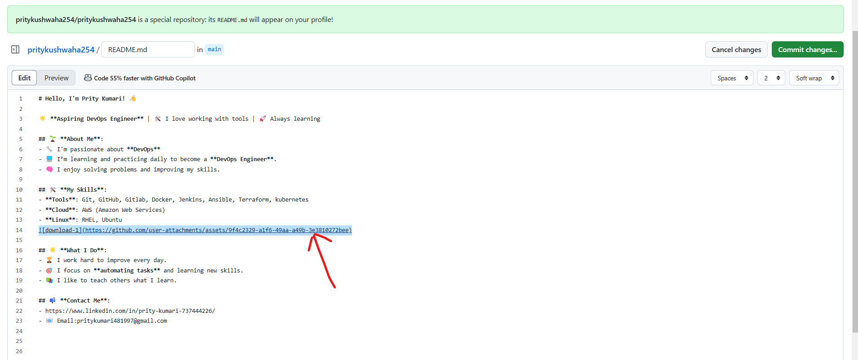

*Click on Commit Changes…*

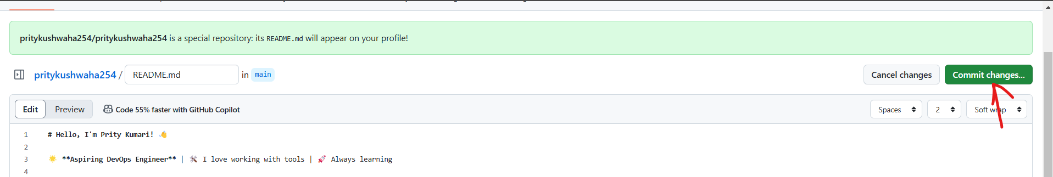

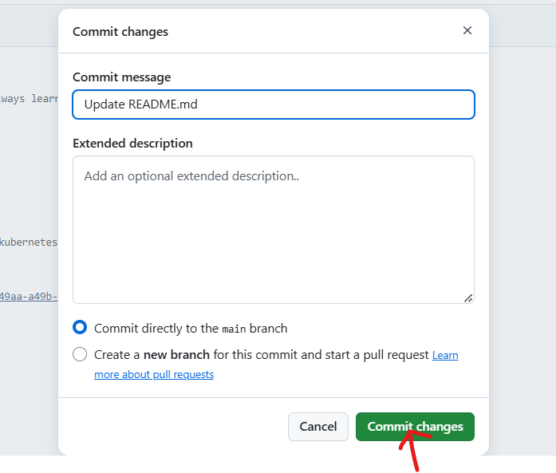

*Your image now* ***publicly visible*** *on your profile.*

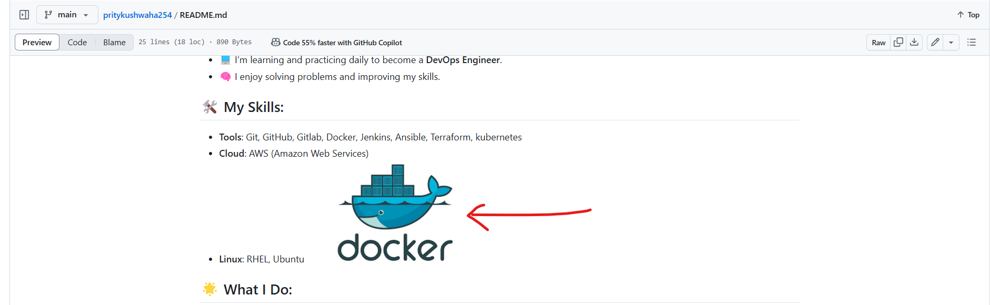

*Your final profile will look like:*

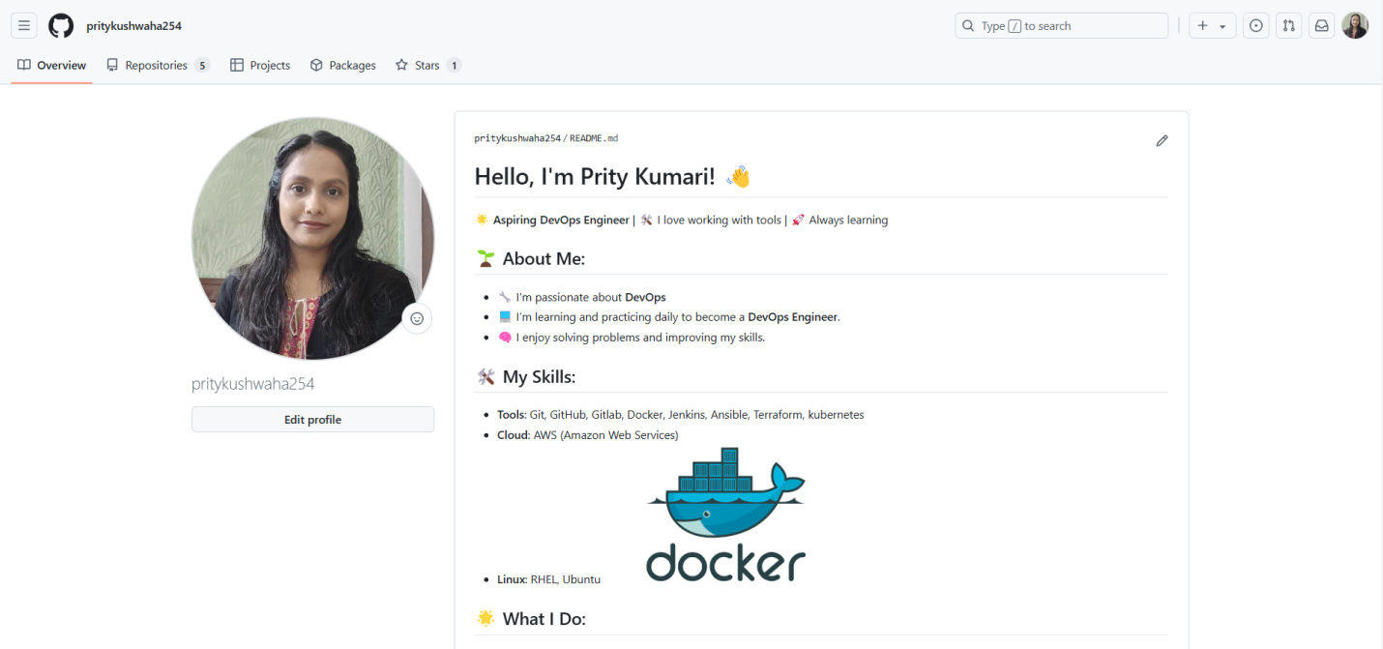

*Your changes along with your information and image now* ***publicly visible*** *on your GitHub Profile!*

*----------------------------------------------------------------------------------------------------------------------------------------------------------------------------------------------------------------------------------*